***Sagar Institute of Science & Technology (SISTec), Bhopal***

***Department of COMPUTER SCIENCE & ENGINEERING***

***Bhopal (M.P.)***

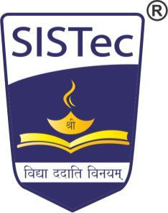

***CERTIFICATE***

I hereby certify that the work which is being presented in the B.E. Minor Project Report entitled **Design and Development LiKerBOT,** in partial fulfilment of the requirements for the award of the degree of ***Bachelor of Engineering*** in ***Computer Science & Engineering*** and submitted to the Department of Computer Science &Engineering, *Sagar Institute of Science & Technology (SISTec)****,*** Bhopal (M.P.) is an authentic record of my own work carried out during the period from July-2019 to October-2019 under the supervision of **Dr. Rajeev Kumar Gupta, Associate Professor.**

The content presented in this project has not been submitted by me for the award of any other degree elsewhere.

**Name Enrolment no. Signature**

Shyam Maurya 0187cs171153

Navneet Purohit 0187cs171089

This is to certify that the above statement made by the candidate is correct to the best of my knowledge.

***Date:***

|  |  |  |
| --- | --- | --- |
| ***Project Supervisor*** | ***HOD PRINCIPAL*** | ***Principal*** |